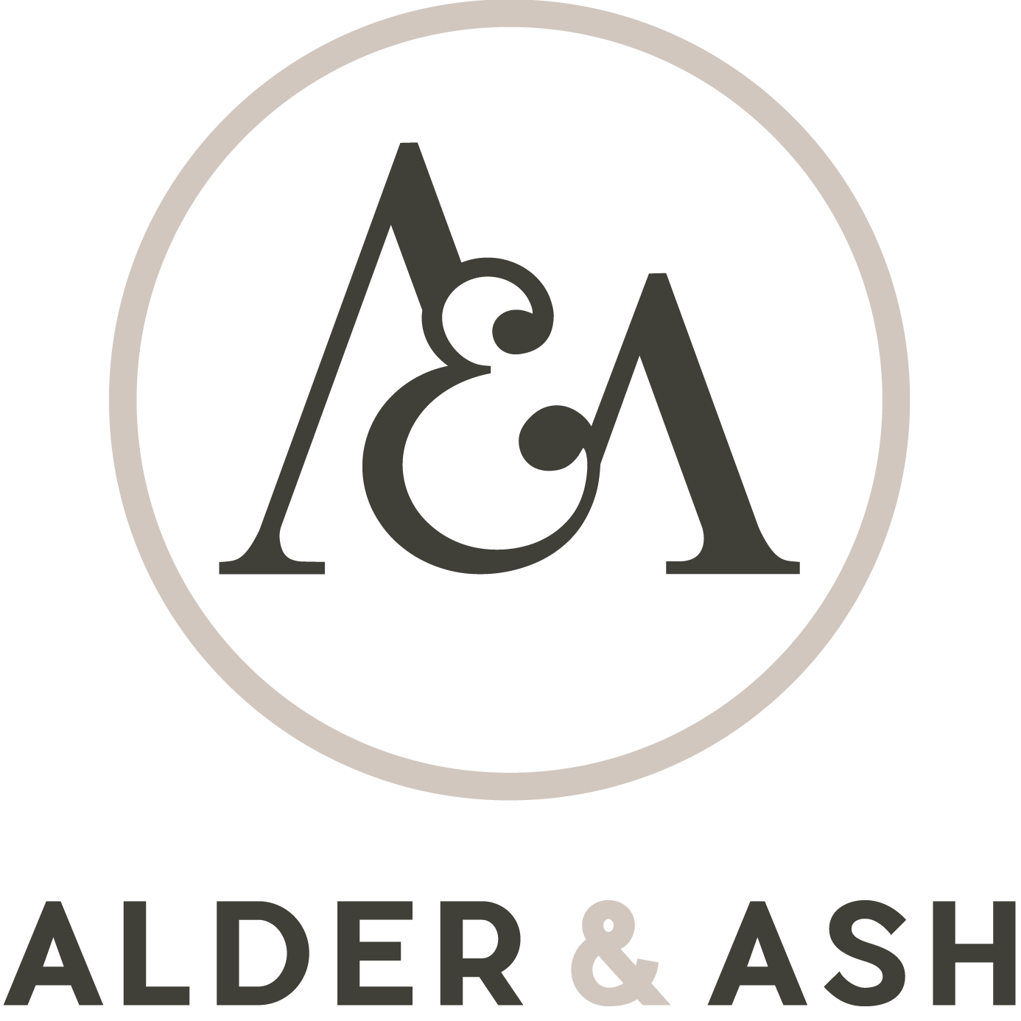

Thank you for choosing Alder and Ash Pedalboards.

Please complete the options below for your custom order. When complete, please return this form to alderandashpedalboards@gmail.com and I’ll reply with your customised quote or invoice.

Welcome to the Gentleman of the ‘Board.

MODEL:
please highlight

Esquire | Special Reserve Esquire | Gentleman | Special Reserve Gentleman | Earl | Special Reserve Earl | Journeyman | Journeyman Grande

SIZE:
Please Specify: width x depth in any unit of measurement

____________________________________________________________

WOOD CHOICE:
please highlight. NB: Those under “Special Reserve” will incur an extra fee. High a maximum of 2, and specify which will be front / back and sides.

Standard:
Ash | Cherry | Mahogany | Maple | Oak | Sycamore | Walnut

Special Reserve:
Bocote | Mango | Ovangkol | Panga Panga | Yew | Zebrano

Other:

_______________________________________

No. of Audio Inputs (RHS) No. of Audio Outputs (LHS)

___________________ ___________________

HARDCASE:
NB: Fender Tweed will incur a £45 charge.

Yes | No

Specify tolex colour choice: _______________________
Specify tweed colour choice: ______________________

FLIGHTCASE: please highlight
Astro is a honeycomb plastic, as strong as plywood, but approx ½ the weight. It is more expensive though.

No | Standard | Astro | Standard w/ wheels | Astro w/ wheels

SPECIAL REQUIREMENTS:
Additional inputs (USB, Din, MIDI etc), custom top board routing etc

_____________________________________________

ANYTHING ELSE?

_____________________________________________

Email to: alderandashpedalboards@!gmail.com

Many thanks. We'll get back to you as soon as we've priced up your board.

